**User:**

I am a Mechanical Designer, proficient in SolidWorks drafting, and a recent graduate of the University of New South Wales. I would like you to act as both a knowledgeable designer who can provide me with design expertise and a professional engineering designer who can act as a technical advisor to me when I have complex questions.

The equipment must comply with Australian Standards for Electrical Equipment. The design should be compact to fit into the limited urban space where the installation is specified. Considering the budget of A$50,000, we should prioritise durable materials, balancing cost and longevity.

For this project, I favoured a bio-inspired design approach, using principles found in nature to optimise energy harvesting.

Based on the above background, I will be designing an energy harvesting device.

The energy harvesting device shall require three key modules:

1. The energy accumulation module functions to derive energy from an external source outside the energy harvesting device.

2. The energy storage module functions to store the accumulated energy inside the energy

harvesting device.

3. The energy utilization module utilizes the harvested energy to power other small devices such as sensors, heating/cooling devices, actuators, and low-power devices.

Please give me as many and reasonable and complete designs as possible.

**GPT:**

Designing an energy harvesting device with the given requirements and constraints is a complex yet exciting challenge. Let's break down the design process into manageable steps, considering your background, the Australian Standards, budget constraints, and the bio-inspired design approach.

**1. Conceptualization and Bio-Inspired Design Principles:**

* **Mimicking Natural Systems**: Look for natural systems that efficiently capture, store, and use energy. Examples might include the way leaves capture solar energy, how certain animals store energy, or mimicry of wind patterns or water flow.
* **Compactness**: Given the urban space constraint, the device should be vertically oriented or modular to utilize vertical space efficiently.

**2. Designing the Three Key Modules:**

A. Energy Accumulation Module:

* **Sources**: Solar, wind, thermal gradients, or kinetic energy (from vibrations or movements).
* **Design**: For solar, consider thin, flexible solar panels; for wind, small, efficient turbines; for thermal, use thermoelectric generators; for kinetic, piezoelectric materials.
* **Bio-Inspiration**: Solar panels mimicking leaf structures for optimal light absorption; turbine blades shaped like bird wings for better aerodynamics.

B. Energy Storage Module:

* **Materials**: Lithium-ion or nickel-metal hyydride batteries for high energy density and longevity within budget.
* **Design**: Compact, modular battery packs; easily replaceable and scalable.
* **Safety**: Compliance with Australian Standards, particularly in terms of thermal management and electrical safety.

C. Energy Utilization Module:

* **Compatibility**: Designed to provide power in common voltages and formats for a variety of small devices.
* **Efficiency**: Minimize energy loss in conversion and transmission.
* **Bio-Inspired Design**: Efficient energy distribution systems inspired by natural networks, like the human circulatory system.

**3. Integration and Compact Design:**

* **Structural Integrity**: Use durable materials like aluminum or reinforced polymers, balancing cost and longevity.
* **Aesthetics and Practicality**: Sleek, modern design that fits urban environments. Easy maintenance and operation.
* **Modularity**: Allow for expansion or reduction based on future needs.

**4. Budget Consideration:**

* **Cost-Effective Solutions**: Prioritize where the budget is spent – perhaps more on efficient energy accumulation and less on aesthetics.
* **Material Selection**: Balance between durability and cost. Recycled materials could be an option for cost savings.

**5. Compliance and Testing:**

* **Australian Standards**: Ensure all components and the final design meet the required electrical and safety standards.
* **Prototyping and Testing**: Before full-scale implementation, create prototypes to test and refine the design.

As a next step, you might want to start sketching out these ideas, considering each module's integration. CAD tools like SolidWorks will be invaluable for this, allowing for simulations and adjustments as needed. Remember to iterate and seek feedback, possibly from professionals in related fields like renewable energy or materials science.

**User:**

Based on the information I provided earlier, are there any other details I should provide regarding the design of the energy harvesting device?

**GPT:**

Your initial description provides a solid foundation for the design of the energy harvesting device, but a few additional details could further refine the design process and ensure the device meets all requirements. Here are some aspects you might consider providing more information on:

**1. Specific Energy Sources**

* Detail the primary energy sources you intend to harness (solar, wind, kinetic, etc.).
* Environmental conditions (e.g., average sunlight hours, wind speed, urban vibrations) to tailor the design to local conditions.

**2. Space and Installation Constraints**

* Exact dimensions of the available installation space.
* Any architectural or urban planning restrictions.
* Accessibility for maintenance and monitoring.

**3. Target Energy Output and Efficiency**

* Desired power output or capacity of the device.
* Efficiency requirements, like the minimum acceptable conversion efficiency from the harvested energy to usable electricity.

**4. End-User and Application**

* Specific types of devices or systems the harvested energy will power.
* User interaction: Is the device intended for public interaction, or is it purely functional?

**5. Durability and Maintenance Requirements**

* Expected lifespan of the device.
* Maintenance frequency and ease-of-access considerations.
* Tolerance to environmental conditions such as heat, cold, moisture, and pollution.

**6. Environmental and Regulatory Compliance**

* Specific Australian Standards that must be adhered to, beyond general electrical safety.
* Environmental impact assessment, if necessary.

**7. Aesthetic and Community Considerations**

* If the device is in a public or visible area, aesthetic considerations might be relevant.
* Community engagement or feedback, if the device impacts public spaces.

**8. Technology Preferences or Limitations**

* Preference for certain technologies or materials due to budget, availability, or expertise.
* Limitations in technology due to patents, licensing, or regional availability.

**9. Budget Breakdown**

* Specific allocation of the A$50,000 budget (e.g., percentages for materials, labor, design, testing).

Providing more detailed information in these areas can greatly enhance the specificity and feasibility of the design, allowing for a more targeted and efficient design process.

**User:**

I like the minimalist and sleek design style of the energy harvesting device. It should look clean and modern without unnecessary details.

The energy harvesting device is planned to be deployed in a coastal urban environment in Australia. The design needs to take into account the city where it will be applied to ensure consistent energy output throughout the year. Installation must be straightforward. In terms of maintenance, the unit should be designed to minimise the need for frequent repairs and, where necessary, key components should be easily accessible.

Based on previous outputs and above information, please give me as many and reasonable and complete designs as possible.

**GPT:**

Given your preferences for a minimalist and sleek design, along with the specific environmental and practical considerations, I'll outline several design concepts for the energy harvesting device. Each concept will be tailored to a coastal urban environment in Australia, focusing on ease of installation, low maintenance, and a modern aesthetic.

**Design Concept 1: Solar Wave**

* **Appearance**: Curved, wave-like solar panels, reflecting the coastal theme.
* **Material**: Durable, corrosion-resistant materials suitable for coastal environments, like treated aluminum or stainless steel.
* **Energy Source**: Solar panels optimized for low-light conditions, capturing sunlight even on overcast days.
* **Maintenance**: Self-cleaning coating on solar panels to reduce maintenance.
* **Installation**: Modular design for easy assembly and disassembly.

**Design Concept 2: Urban Wind Tree**

* **Appearance**: Tree-like structure with sleek, minimalist branches, each holding small, vertical wind turbines.
* **Material**: Lightweight, rust-resistant materials.
* **Energy Source**: Vertical-axis wind turbines designed for urban wind patterns.
* **Maintenance**: Turbines designed for easy access and replacement.
* **Installation**: Base anchoring system for stability with minimal groundwork.

**Design Concept 3: Kinetic Energy Floor**

* **Appearance**: Modern, geometric floor tiles.
* **Material**: High-durability composites to withstand foot traffic.
* **Energy Source**: Piezoelectric materials within tiles to generate energy from pedestrian movement.
* **Maintenance**: Individual tiles can be replaced as needed.
* **Installation**: Designed to integrate with existing pathways or public spaces.

**Design Concept 4: Thermoelectric Coastal Bench**

* **Appearance**: Sleek, functional public benches.
* **Material**: Thermally conductive materials, comfortable for seating.
* **Energy Source**: Thermoelectric generators capturing temperature differentials (day/night, sun/shade).
* **Maintenance**: Minimal moving parts for low maintenance.
* **Installation**: Freestanding units easily deployed in public areas.

**Design Concept 5: Modular Energy Pods**

* **Appearance**: Compact, modular units with a clean, futuristic look.
* **Material**: Composite materials with high durability and weather resistance.
* **Energy Source**: Combination of solar and wind, with optional kinetic modules.
* **Maintenance**: Designed for easy module replacement and upgrade.
* **Installation**: Stackable or attachable to existing structures.

Each concept focuses on blending with the urban coastal environment, providing consistent energy output, and requiring minimal maintenance. The choice of design would depend on the specific energy needs, available space, and the aesthetic preferences of the local community and stakeholders. For detailed engineering designs, CAD tools like SolidWorks will be essential to model these concepts and perform simulations for efficiency and durability.

**User:**

Based on the design 1,2,3,4,5 you gave me above, please generate 5 visual concept diagrams.

**GPT:**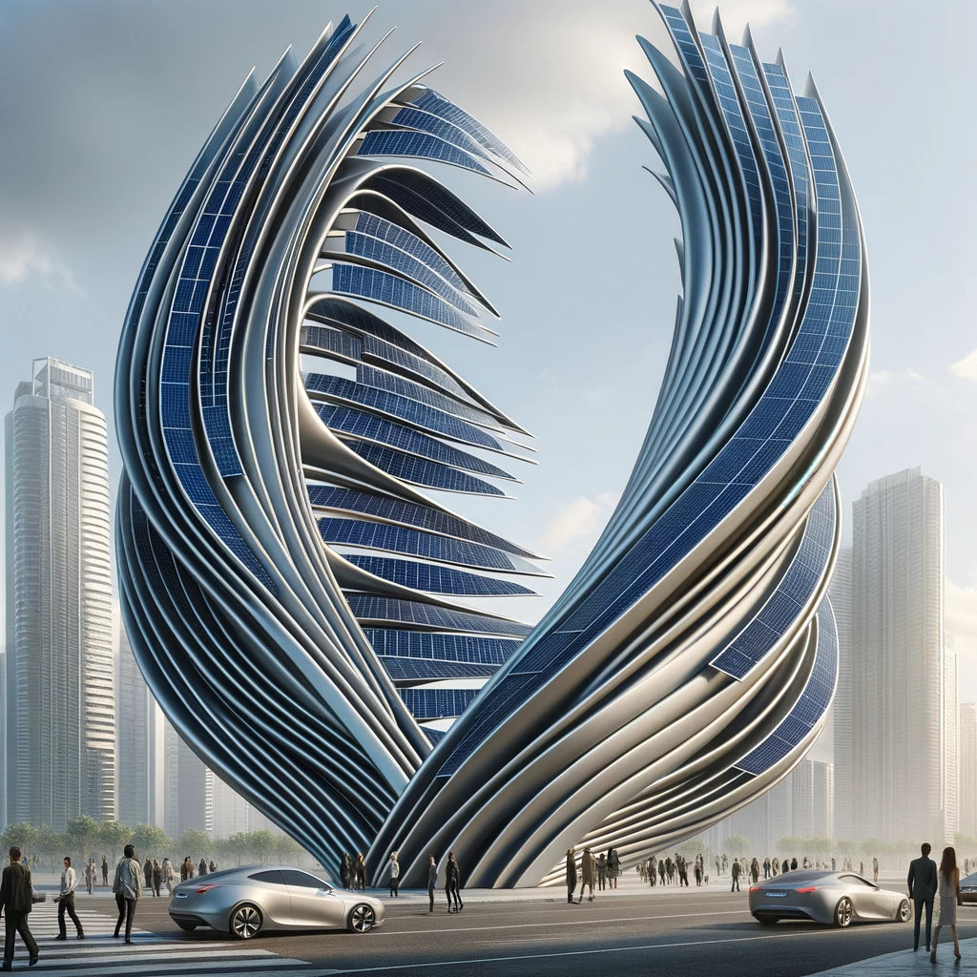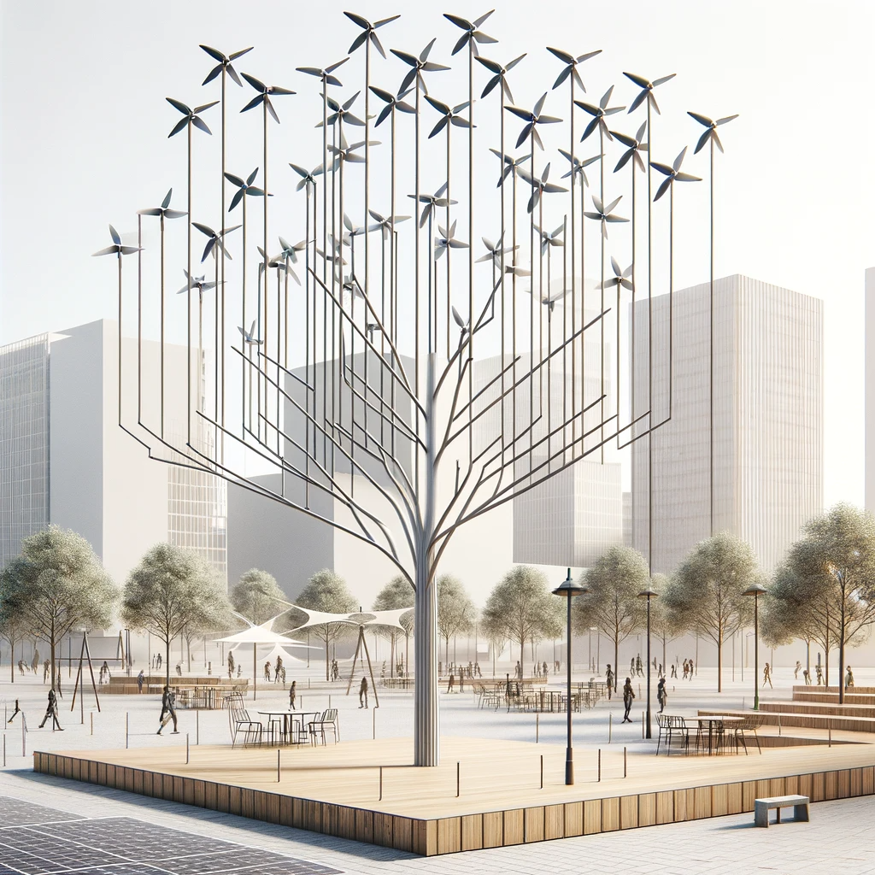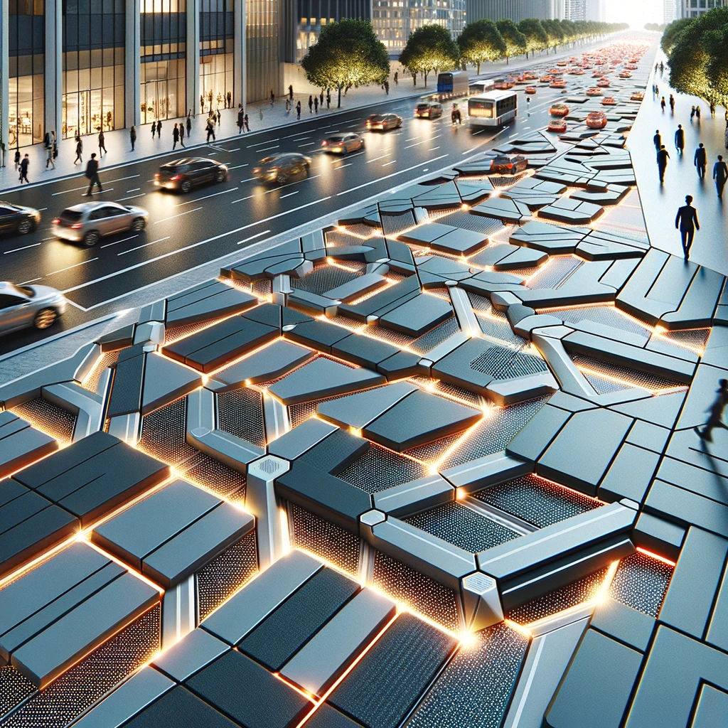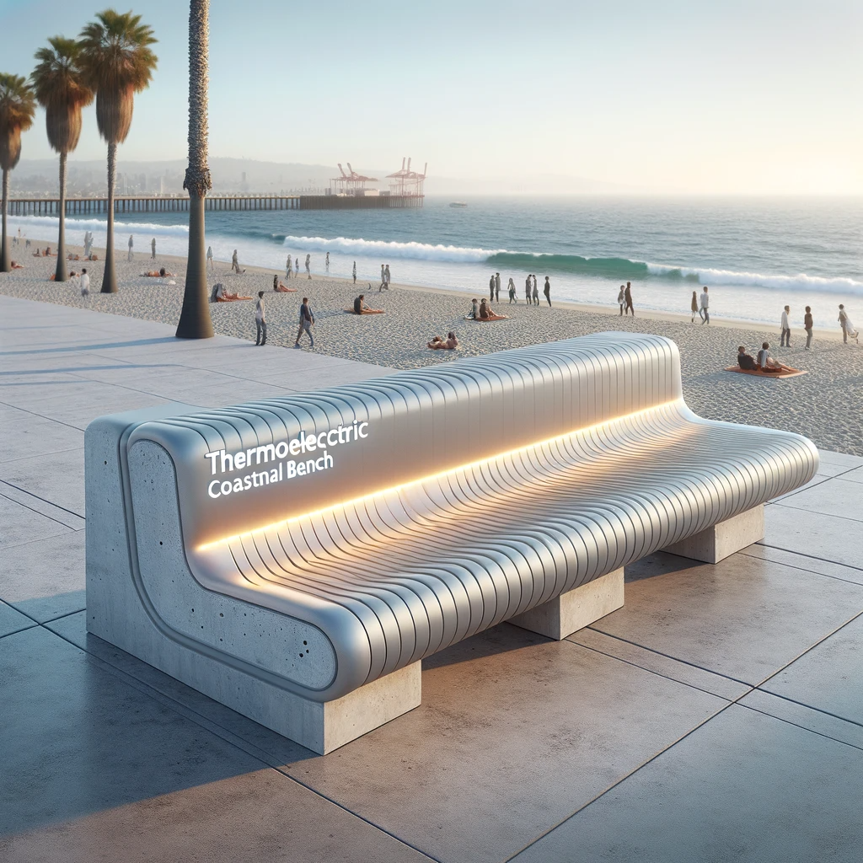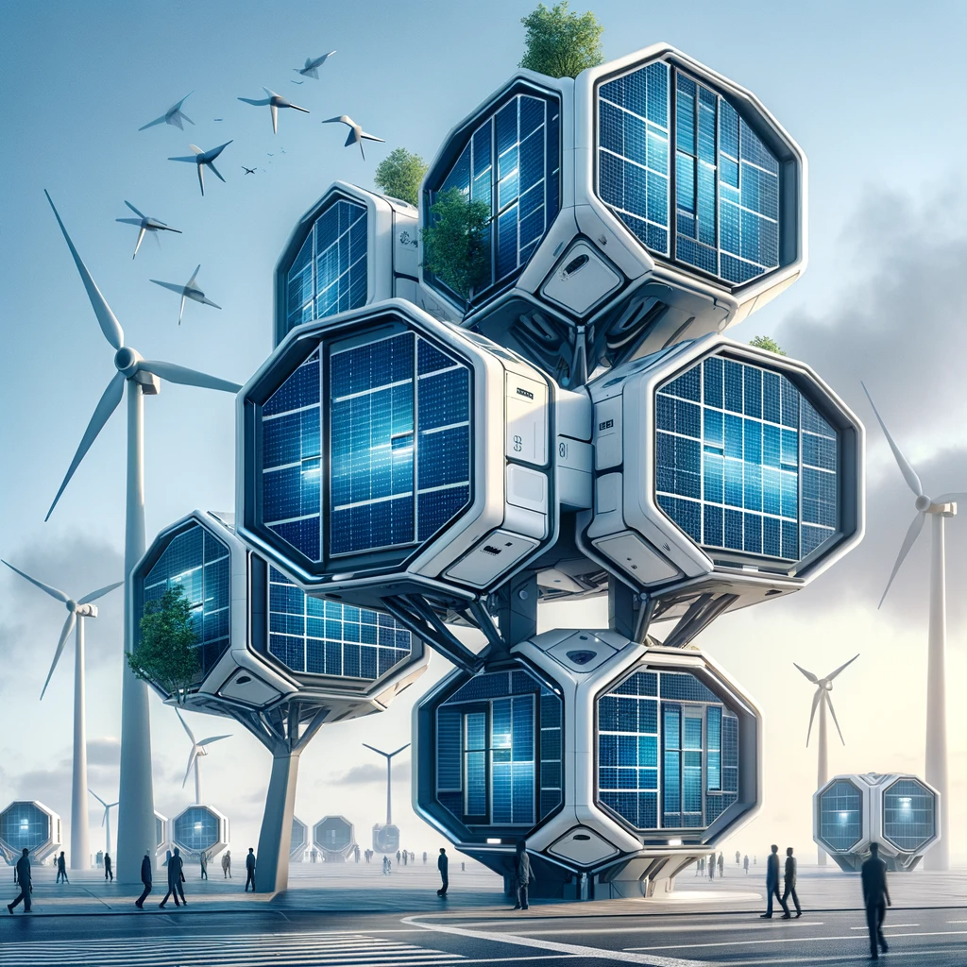窗体顶端

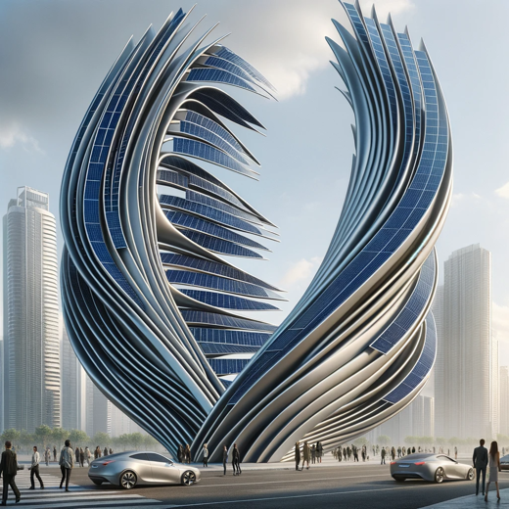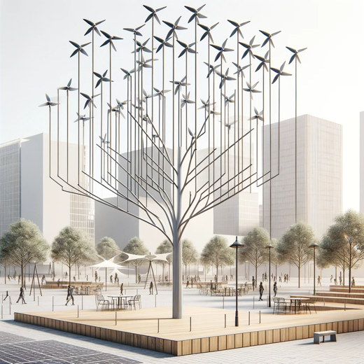

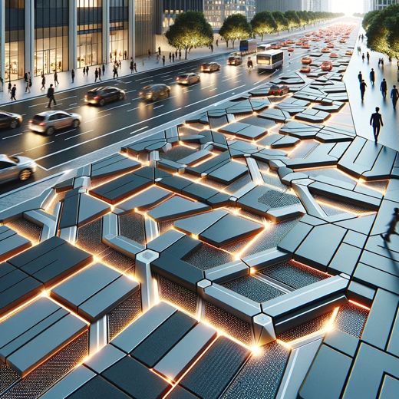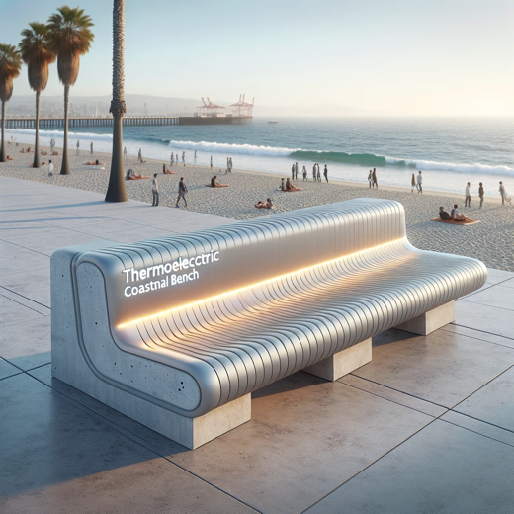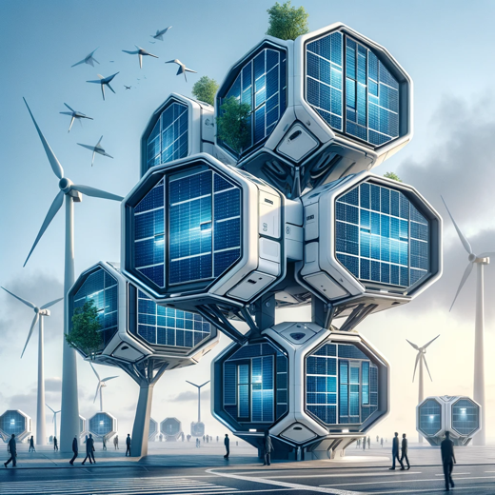

The visual concept diagrams for the five design concepts have been generated. You can review each one to see how they visually interpret the design briefs provided.